Wig Care

Getting Started with Your Wig
- Hold the wig by the front at your forehead and slip it over your head.
- Make sure the two wig tabs are placed in front of your ears and set on your temples.
- Keep your ears pulled out from under the wig.
- Pull the wig down in the back to secure it and make sure that the front of the wig begins at your natural hairline.
- Use the hooks or fabric fastener, in the back of your wig to adjust the fit.
- Test the fit and comfort of your wig by wearing it at home for a few hours.
- If this is your first time wearing a wig, allow yourself some time to let the awkwardness pass.
- A good wig shop, stylist or a trained volunteer at a Look Good Feel Better group program can help you get accustomed to putting on your wig.

Scarf Tips
Scarves open up a world of color and style. Choose according to season, occasion, or whim. Endless styling possibilities make scarves an attractive daily or special-occasion option.

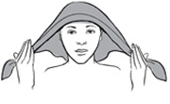

Scarf Tips
- Use a simple 32- to 36-inch square to create a full head covering.
- Use a smaller square or oblong as a band.
- Choose a scarf appropriate to the season and occasion.
- Choose colors and patterns that coordinate with what you are wearing. Two patterns in the same color will add texture and interest to your look.
- Silk is elegant, but tends to slip.
- Cotton is great, casual option – it’s cool and easy to keep in place.
- Wool challis scarves can be itchy, but drape beautifully.
- Coordinate scarves with clothes that have softer lines.
Scarf Basics
Fold a large square diagonally, drape it low over your forehead, and try some of the following techniques.

Looping
- Tie the ends in a bow over the point.

Bundling
- Knot the ends, fold the point around the bundled ends, and then secure it inside the band.
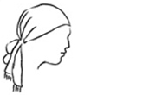

Coiling
- Cross the ends over the point and coil to the front. Intertwine, or braid, the coils to make one long, continuous band. Fold the point up into the crossed area.
- If the scarf is too small, fold it off-center to make a larger cap. If the ends are short, band with a second scarf and finish with a good-looking tie.
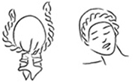
Scarf Techniques

Bow
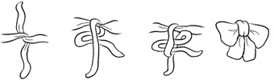
Tie ends in a half-knot. Form the first loop with the lower tied end. Then bring the other end over and around the first loop and continue partially through the opening that is formed, making the knot and second loop. Flare the loops and spread center.
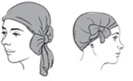

Square knot
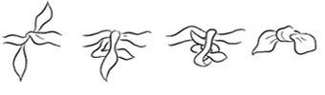
Tie a half-knot. Bring the upper end down over the lower piece. Keep looping around the lower end and come through the opening. Flare endings and spread center knot.
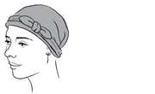

Rosette
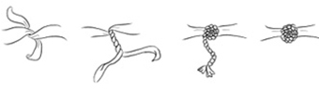
Tie a half-knot, leaving the ends long. Tightly intertwine the ends to form a coil, leaving a short length uncoiled. Relax the coil and guide it around itself. Poke the end of the coil partway through the center of the circle. Spread the sash-ends to ruffle around the rosette.
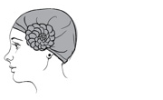

Half-bow
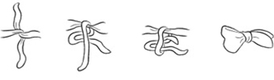
Tie the ends in a half-knot, making the lower end twice as long as the upper end. Make a loop with the lower end. Then bring the upper end down over the loop. Go around the lower loop and bring the whole scarf-end completely through the opening. Flare the loop and spread the knot.
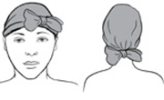

Band
Fold opposite corners of a square to the center, overlap points, and fold again to desired width.

Coil
Twist a band from the center out, for an even coil. Several simple, decorative head wraps may be created this way.

